**GOVERNMENT ARTS COLLEGE, OOTY**

**DEPARTMENT OF ELECTRONICS AND COMMUNICATION SYSTEM.**

**MEASURING SUCCESS IN TALENT MANAGEMENT**



MENTOR: Dr. J. MANIKANDAN

*Submitted By*

TEAM LEADER: KARTHICK.K (2126B0050)

TEAM MEMBER 1: KARTHICK.K (2126B0050)

TEAM MEMBER 2: LIDWIN MATHEW.J (2126B0052)

TEAM MEMBER 3: MOHAMMAD HUSSAIN.S (2126B0054)

TEAM MEMBER 4: REBEKAH ROSE.S (2126B0055).

**GOVERNMENT ARTS COLLEGE , UDHAGAMANDALAM**

**DEPARTMENT OF ELECTRONICS AND COMMUNICATION SYSTEM.**

**MEASURING SUCCESS IN TALENT MANAGEMENT**

MENTOR: Dr. J. Manikandan

TEAM LEADER: KARTHICK.K

TEAM MEMBER 1: KARTHICK.K

TEAM MEMBER 2: LIDWIN MATHEW.J

TEAM MEMBER 3: MOHAMMAD HUSSAIN.S

TEAM MEMBER 4: REBEKAH ROSE.S

**1.INTRODUCTION**

**1.1: OVERVIEW**

Certainly! Measuring success in talent management is a critical aspect of human resources and organizational development. It involves a systematic approach to assess the efficiency and impact of talent-related strategies within an organization. This process aims to ensure that the right people are in the right roles, they are motivated and engaged, and their skills are continuously developed to meet the organization's goals. Effective measurement in talent management includes evaluating recruitment and onboarding processes, employee performance and productivity, training and development initiatives, as well as employee engagement and satisfaction levels. These measurements provide valuable insights into the effectiveness of talent acquisition, employee development programs, and overall organizational culture.

**1.2 PURPOSE**

Assessing the effectiveness of talent management strategies and programs in achieving organizational goals. Identifying areas where resources can be allocated most effectively to attract, develop, and retain talent. Providing data to inform long-term talent strategies, such as workforce planning and succession planning. Helping organizations gain a competitive edge by ensuring they have the right talent in the right roles. Gauging the impact of talent management on employee satisfaction, engagement, and retention. Ensuring organizations adhere to legal and ethical standards, promoting diversity, equity, and inclusion. Identifying opportunities to reduce recruitment and turnover costs. Identifying and developing future leaders within the organization. In essence, measuring success in talent management enables organizations to optimize their workforce, enhance performance, and achieve their strategic objectives.

**2.PROBLEM DEFINITION & DESIGN THINKING**

**2.1: EMPATHY MAP**

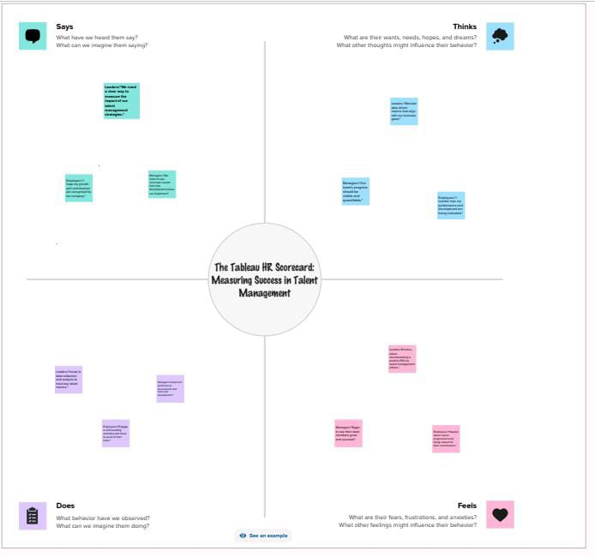

**2.2: IDEATION & BRAINSTROMING MAP**



**3.RESULT**

**3.1: DASHBOARD**

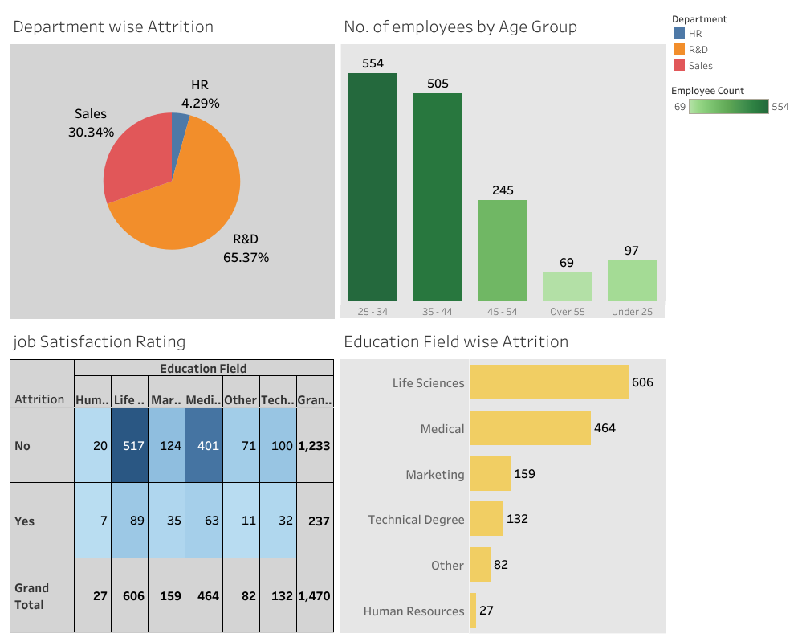

**3.2: STORY**

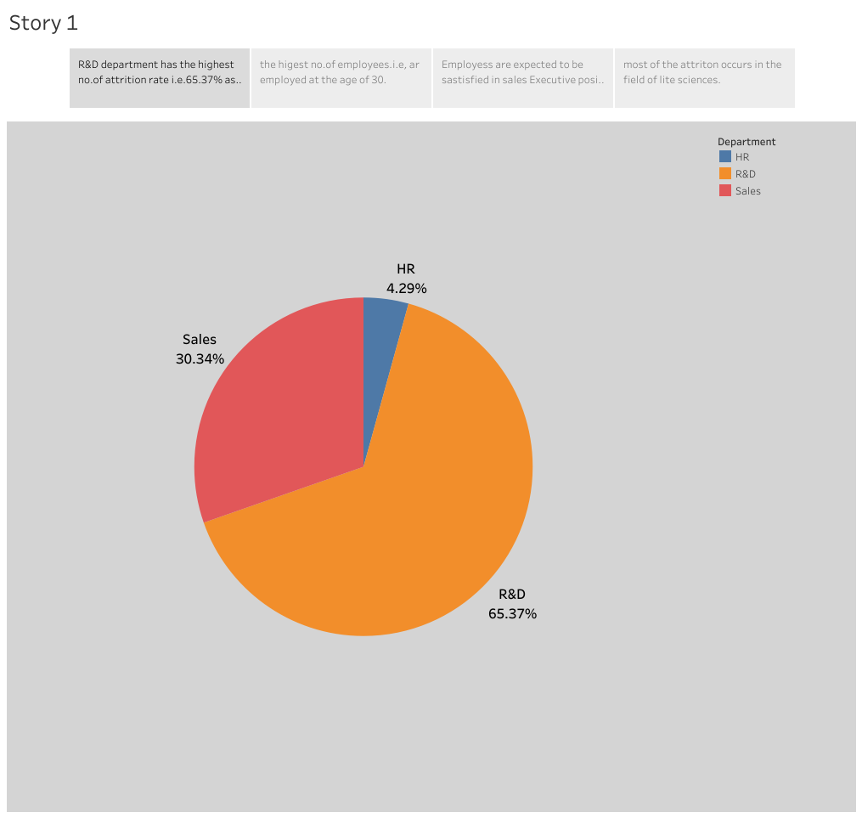

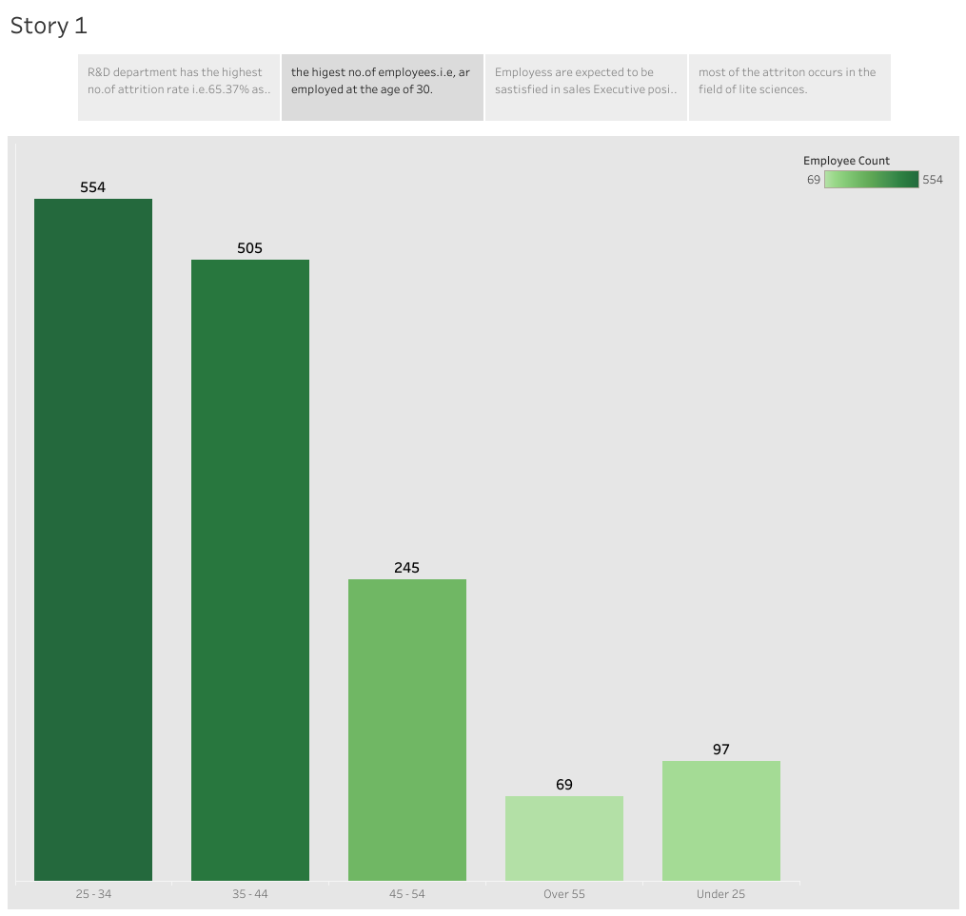

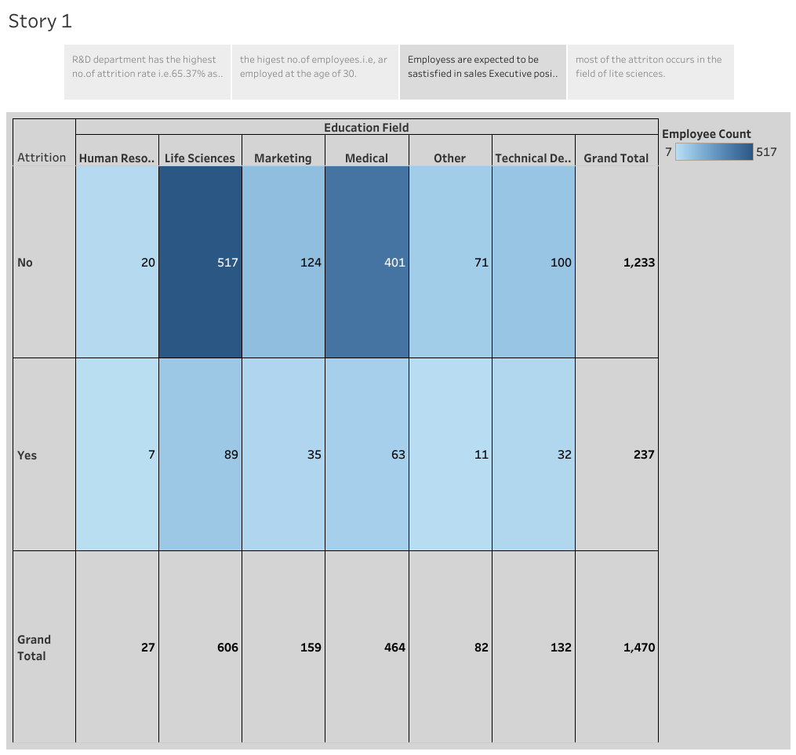

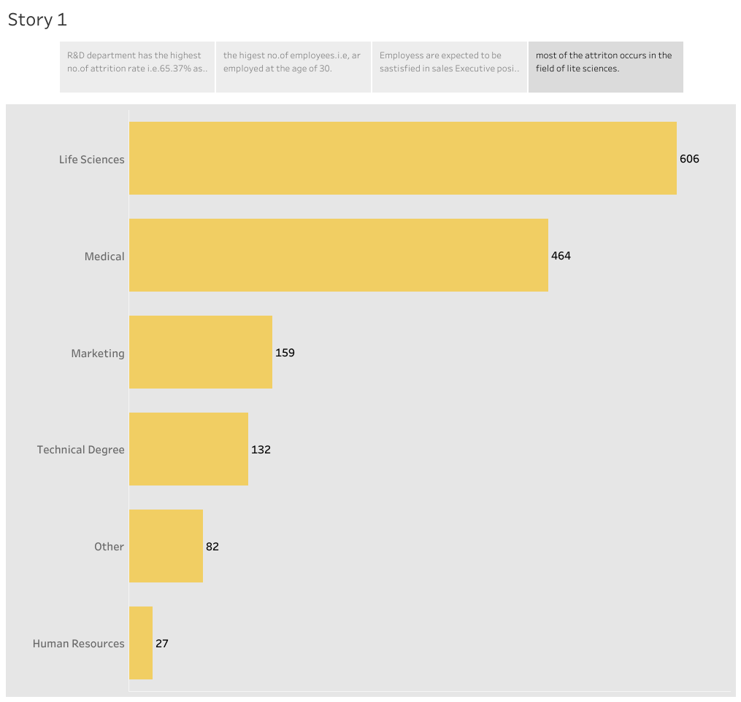

**3.3: WEB APPLICATION**

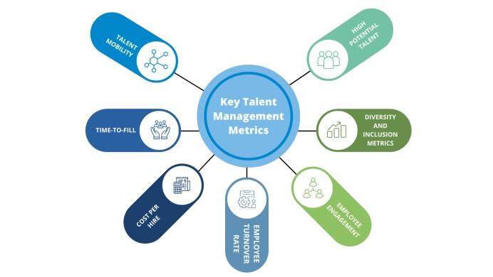

**4.ADVANTAGES & DISADVANTAGES**

**4.1: ADVANTAGES OF MEASURING SUCCESS IN TALENT MANAGEMENT**

**Improved Decision-Making**: Data-driven insights enable informed decisions regarding recruitment, development, and retention of talent.

**Resource Allocation**: It helps allocate resources effectively by focusing on strategies that yield the best results.

**Enhanced Performance**: Identifying and nurturing high-potential employees can lead to improved overall organizational performance.

**Competitive Edge**: Effective talent management can give an organization a competitive advantage in the market.

**Employee Engagement:** By gauging and improving factors like job satisfaction and development opportunities, it can boost employee morale and engagement.

**Compliance and Diversity:** It ensures adherence to legal and ethical standards while fostering a diverse and inclusive workplace.

**Cost Savings:** Success metrics can reveal areas where costs can be reduced, such as lowering turnover and recruitment expenses.

**Succession Planning**: Identifying and developing future leaders within the organization ensures long-term sustainability.

**Talent Retention**: Focusing on the development and retention of existing talent can reduce the need for external recruitment. **Alignment with Strategic Goals:** Measuring success helps ensure that talent management efforts are aligned with the organization's strategic objectives. In summary, measuring success in talent management is a strategic approach that can lead to a more efficient and effective workforce, ultimately benefiting the organization's bottom line and long-term sustainability.

**4.2: DISADVANTAGES OF MEASURING SUCCESS IN TALENT MANAGEMENT**

**Overemphasis on Metrics:** Relying too heavily on metrics can lead to a narrow focus on quantitative data, potentially overlooking qualitative aspects of talent management.

**Data Quality Issues**: Inaccurate or incomplete data can lead to flawed decisions and strategies if not properly addressed.

**Resistance from Employees**: Employees may feel pressured or under surveillance, impacting morale and engagement if metrics are not used sensitively.

**Complexity**: Developing and maintaining a comprehensive measurement system can be time-consuming and complex.

**Costs**: Implementing measurement systems and data analysis can be costly, especially for smaller organizations.

**Risk of "Gaming" the System**: When employees or managers are overly focused on achieving specific metrics, they may engage in behavior that prioritizes meeting those metrics over genuine performance improvement.

**Stifling Creativity:** A strict focus on metrics can hinder creative thinking and innovation, particularly in roles that don't have easily quantifiable outcomes.

**One-Size-Fits-All Approach:** Metrics may not account for the unique needs of different job roles or industries, leading to inappropriate measurement criteria.

**Time Lag:** Some talent management outcomes, such as the impact of training and development, may take time to manifest, making it challenging to assess their effectiveness in the short term.

**Inflexibility:** An overreliance on metrics can make organizations slow to adapt to changing circumstances or emerging talent management trends.To address these disadvantages, organizations should use a balanced approach to talent management measurement, incorporating both quantitative and qualitative assessments while considering the specific needs and culture of their workforce.

**5.APPLICATIONS**

Measuring success in talent management involves various key performance indicators (KPIs) and metrics. Here are some common ones:

**1. Employee Retention Rate:** This metric measures the percentage of employees who stay with the company over a specific period, indicating the effectiveness of talent retention strategies.

**2. Hiring Time:** The time it takes to fill a vacant position. A shorter hiring time can indicate efficient recruitment and onboarding processes.

**3. Performance Appraisals:** Regular performance reviews can help measure individual and team performance against established goals.

**4. Employee Satisfaction Surveys:** Gathering feedback from employees can gauge their overall satisfaction, engagement, and well-being.

**5. Turnover Rate:** Tracking turnover rates, especially among high-performing employees, helps assess talent retention efforts.

The specific metrics you use should align with your organization's goals and objectives, and they may vary across industries and companies. Regularly reviewing and analyzing these metrics can help you assess the effectiveness of your talent management strategies and make data-driven decisions to improve them.

**6.CONCLUSION**

In conclusion, measuring success in talent management is a multifaceted process that relies on a combination of key performance indicators and metrics. By effectively evaluating these metrics, organizations can gain valuable insights into the performance of their talent management strategies. This data-driven approach enables them to make informed decisions, optimize recruitment and retention efforts, enhance employee development, and ultimately foster a more productive and engaged workforce. The choice of specific metrics should align with the organization's unique goals and objectives, ensuring that talent management efforts lead to sustainable success and long-term growth.

**7.FUTURE SCOPE**

The future scope for measuring success in talent management is poised for continuous evolution and transformation, driven by technological advancements, changing workforce dynamics, and the growing importance of talent in organizations. The future of talent management measurement lies in harnessing technology, embracing agility, and aligning with the changing needs and expectations of the workforce. Organizations that adapt and leverage these emerging trends in talent management metrics will be better equipped to attract, retain, and develop top talent in the years ahead.

***THANK YOU...!***